**Library Application (Week 12)**

**Preparation**

Before you work on this project, you need to install something called “plotly” on your computer. “Plotly” is a Python package that allows you to draw charts.

Open an Anaconda command prompt window. Type the command “**conda install plotly**”, as you can see below. Type “**y**” if you’re asked whether you want to proceed. See the picture below for an example (but your installation process may show different packages to be downloaded).

Once plotly is installed properly, you can continue.

**Overview**

In this exercise, you will be implementing some functions to help build a web-based library application.

After you unzip “LibraryApplicationStartingCode.zip”, run “python main.py” in Anaconda command prompt window. Open your browser and visit the local link given in the Anaconda Prompt window. You will see the following page in your browser:

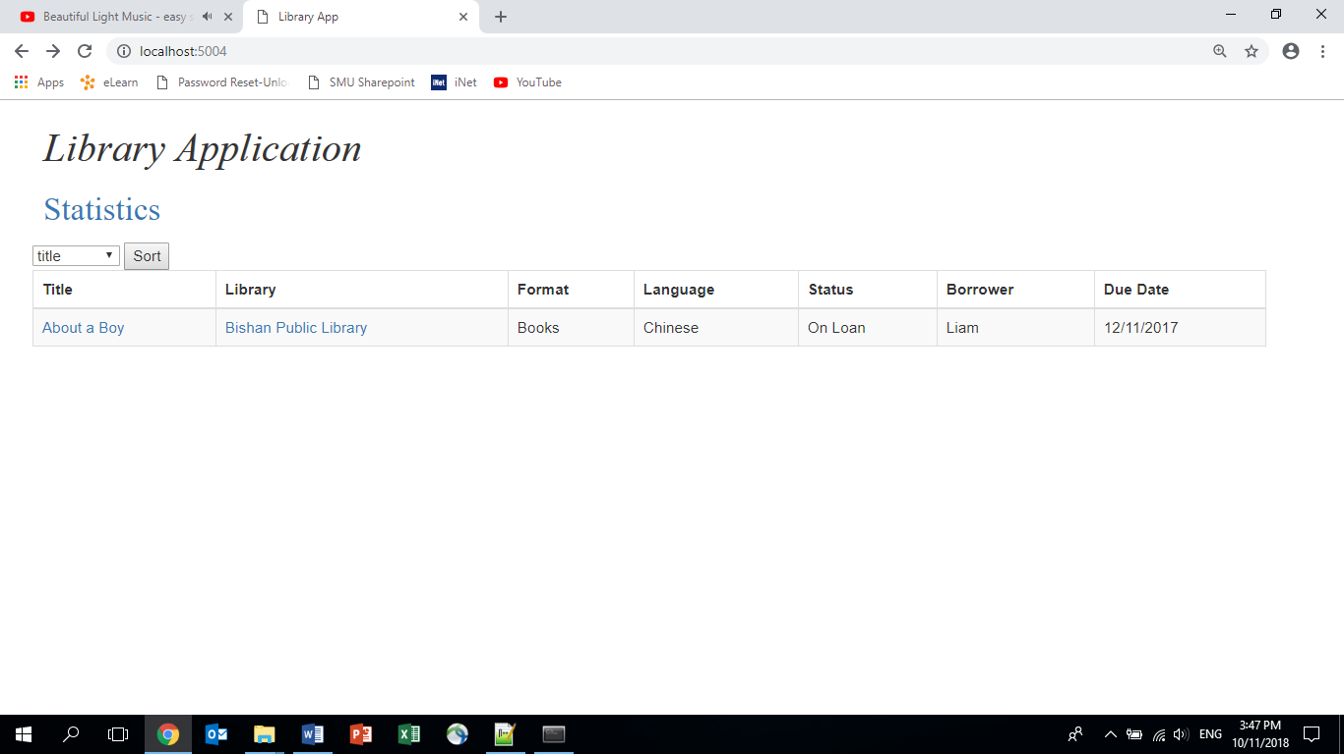

You can see that the application is not finished at the moment. Follow the steps below to complete the application.

**Q1: Listing all Items [*]**

Right now, on the main webpage you will see only a single item, which is a test item. Your job is to modify the function called **read_items_from_file()** in the file “**util.py**”. This function is supposed to read the file given as the parameter of the function and return a list of tuples. You can open the file “**static/items.txt**” to see how the file looks like. Follow the instruction inside the function to implement the function.

When this function is properly implemented, you should see all the items found in “static/items.txt” properly displayed on the main webpage, as shown in the incomplete picture below:

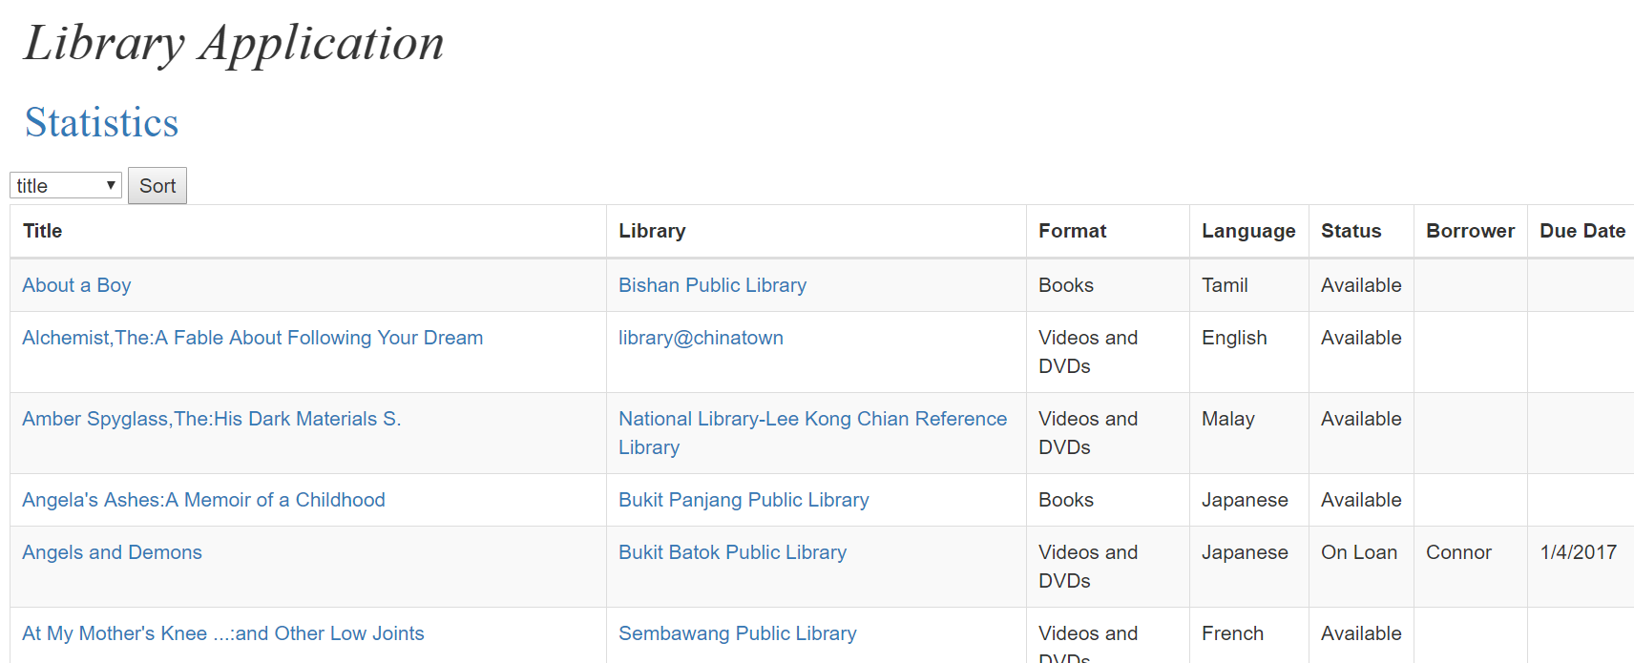

**Q2: Listing Items of a Library [**]**

You’ll see that each library has a hyperlink. Right now when you click on the link of a library, you see a table with the test item, as shown below. Supposedly this table should display all the items belonging to that library.

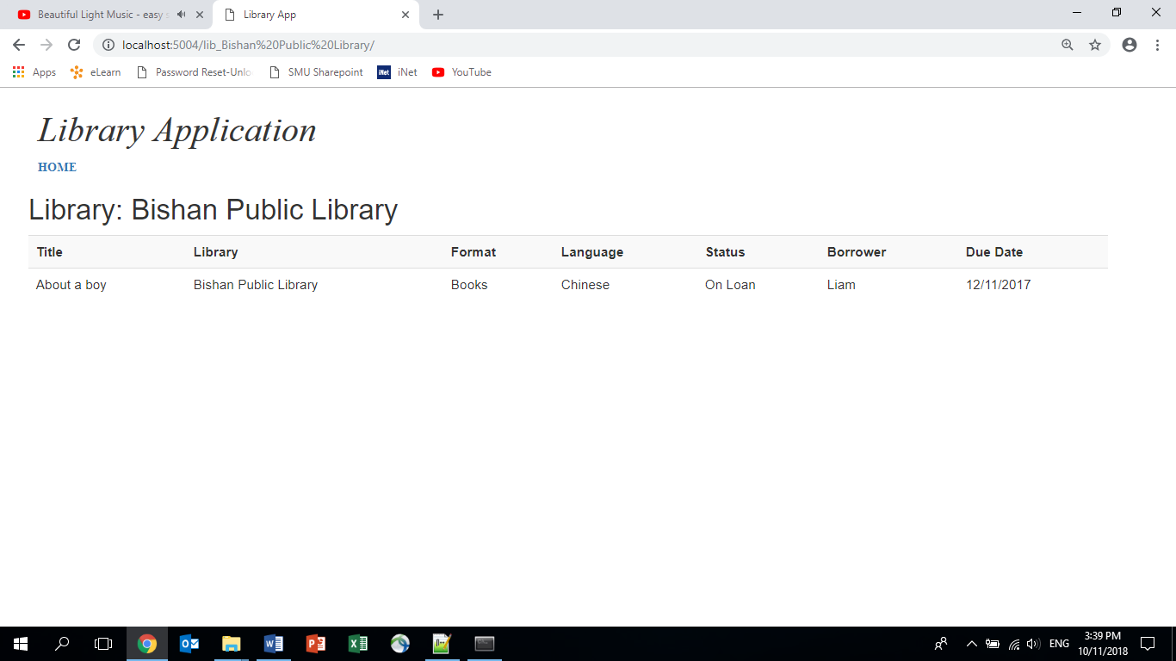

Implement the function called **read_items_of_given_library_from_file()** in “**util.py**”. This function takes in the same file as the previous function but returns only items from a given library.

When this function is properly implemented, you should see all the items of a certain library displayed on the page of that library, as shown below:

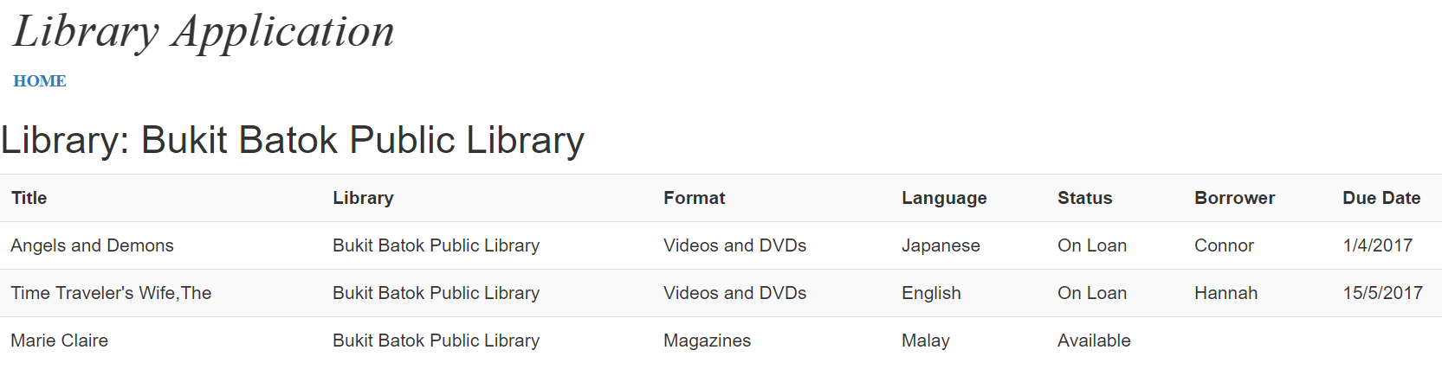

**Q3: Plotting Data Statistics [***]**

You’ll see a link called “Statistics” below “Library Application”. This page is supposed to show some statistics of the data through some pie charts and bar charts. However, currently the charts are not shown properly. See the picture below for the current page:

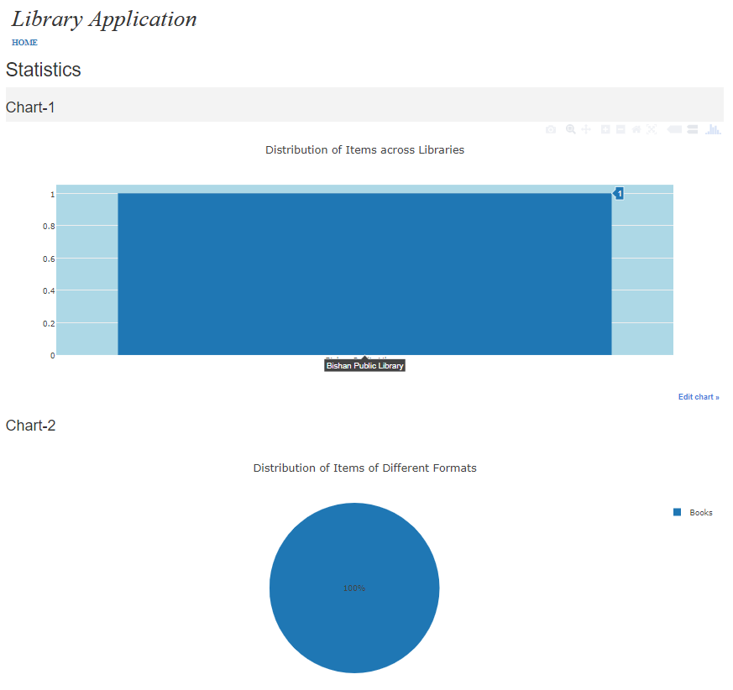

Your job is to implement the following functions in “util.py” so that these charts can be displayed properly.

* get_item_counts_by_library
* get_item_counts_by_format
* get_item_counts_by_language

Note that these three functions are very similar. Once you can implement the first one, the other two can be implemented in a very similar way.

When these functions are implemented properly, you should see the following page:

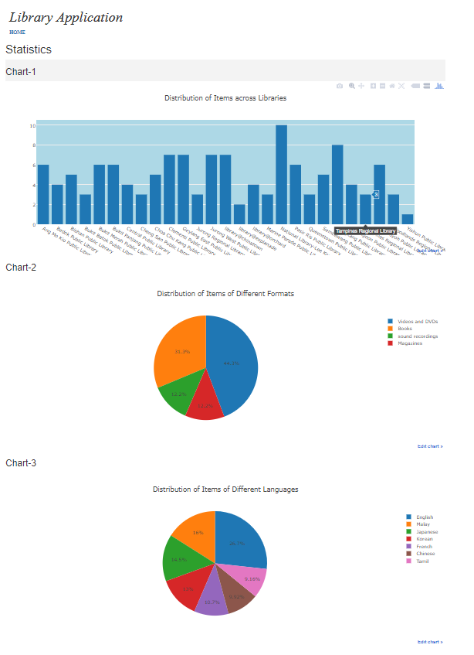

**Q4: Listing Loan History of Items [***]**

You’ll see that the title of each item is a hyperlink. When this link is clicked on, the loan history of that item should be displayed in a table.

Right now when you click on the title “About a Boy”, you’ll see the following page:

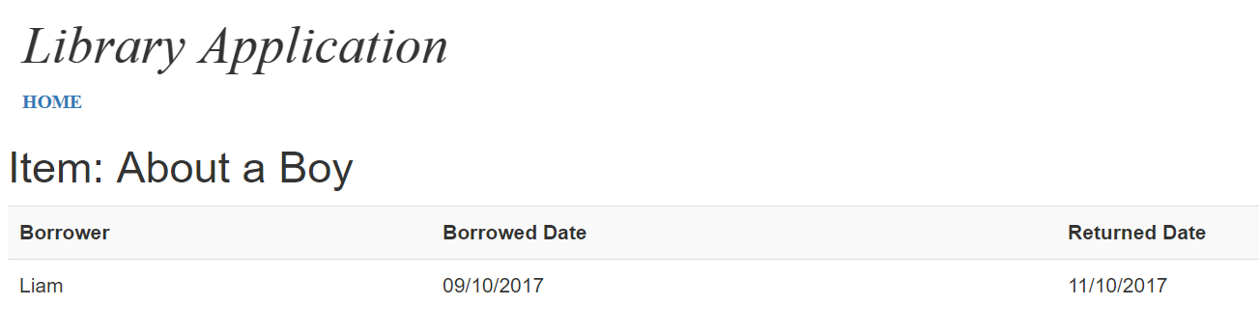

When you click on other titles, you’ll get errors.

Your job is to implement the function called **read_loans_from_file_to_dict()** in “util.py”. This function takes in the name of a file as its parameter. Open the file “**static/loans.txt**” to see how the file looks like. Follow the instructions inside the function to implement the function.

When this function is properly implemented, for each item, when its title is clicked, you should see the loan history of that item.

